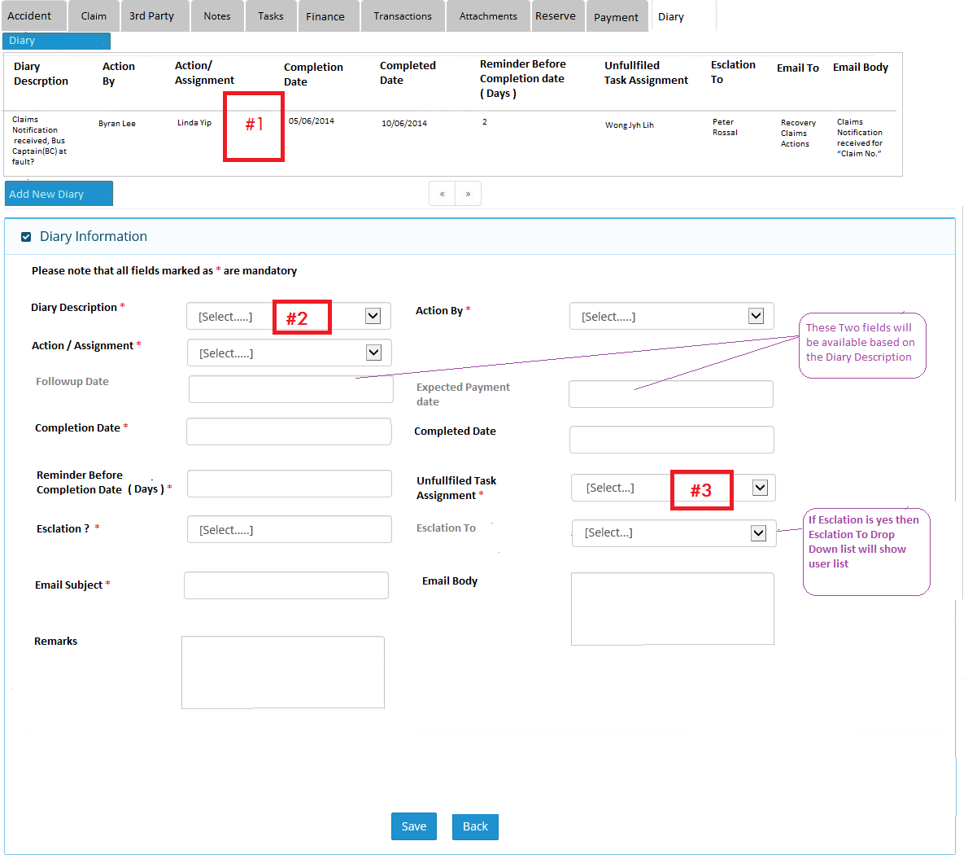

Points:

#1 – All outstanding tasks will be displayed here or should there be a filter to display all diary tasks – completed and outstanding

[PK- 2Jul14]: BY Default, system will display only filtered outstanding tasks. System will give flexibility to show all the dairy tasks for that claim.

#2 – Will it be all the tasks as highlighted in the documents and is there any duplicate tasks validation?

[PK - 2July14]: Yes, this dropdown will have all the tasks mentioned in the documents. Like below

|  |  |
| --- | --- |
| S.no. | Diary Description |
| 1 | Claims Notification received, Bus Captain(BC) at fault?  Yes/No |
| 2 | Pending Documents |
| 3 | Case Assignment |
| 4 | LOD Sent |
| 5 | Set Case Review Date |
| 6 | Settlement Reached |
| 7 | Payment Received |
| 8 | Case Assignment |
| 9 | Property Claims |
| 10 | Injury Claims – Claims Amount more than $15k |
| 11 | Injury Claims – Claims Amount less than $15k |
| 12 | Update Claim Development |
| 13 | Review Of Claim |
| 14 | Writ of Summons (WOS) Received |
| 15 | Case Resolved. Payment Required |
| 16 | Total Payment >15K |
| 17 | Debit Note Approved by SV |
| 18 | Payment Processing |
| 19 | Payment Settlement |

#3 - Can this re-assignment be on block basis (user able to select multiple users) to handle staff on leave cases?

[PK - 2July14]: we can provide multiple selections from users list. For more details of functionality, we may need discussion.